TEMPLATE REPORT PROJECT

IREVOLUTION : A DATA-DRIVEN EXPLORATION OF APPLE’S IPHONE IMPACT IN INDIA

NM ID:NM2023TMID37177

1. INTRODUCTION

The introduction of the iphone in India has significantly impacted technology adoption, consumer behaviour, and the economy. This exploration will examine the I phone’s influence on smartphone trends, user preference, and its broader socio-cultural implications in the country.

1. PURPOSE

The purpose of exploration the impact of Apple’s iphone in India is to understand how it has influenced technology adoption, consumer behaviour, and the economy. This exploration aims to assess the extent of its impact on the Indian smartphone market, socio-cultural changes, and economic contributions, while addressing the challenging and the opportunities that have arisen as a result

1. PROBLEM DEFINITION AND DESIGN THINKING

Empathy Map

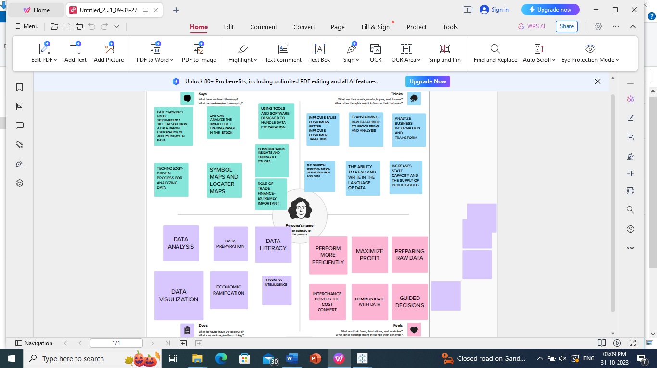

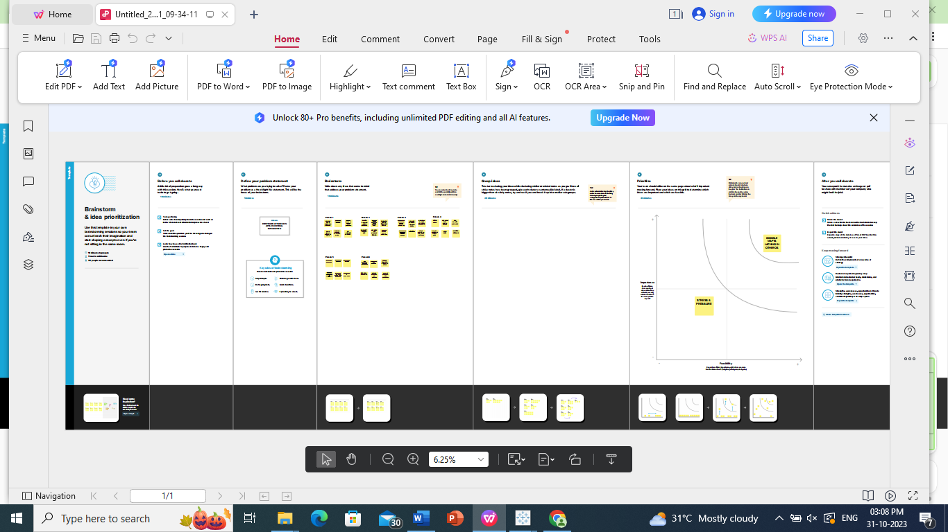

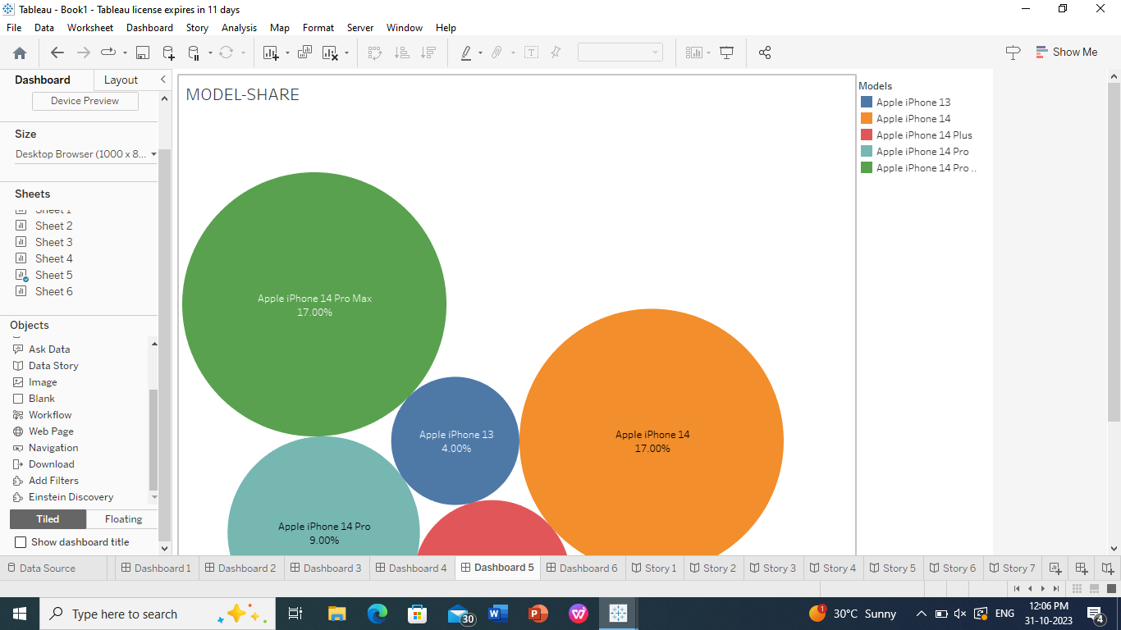

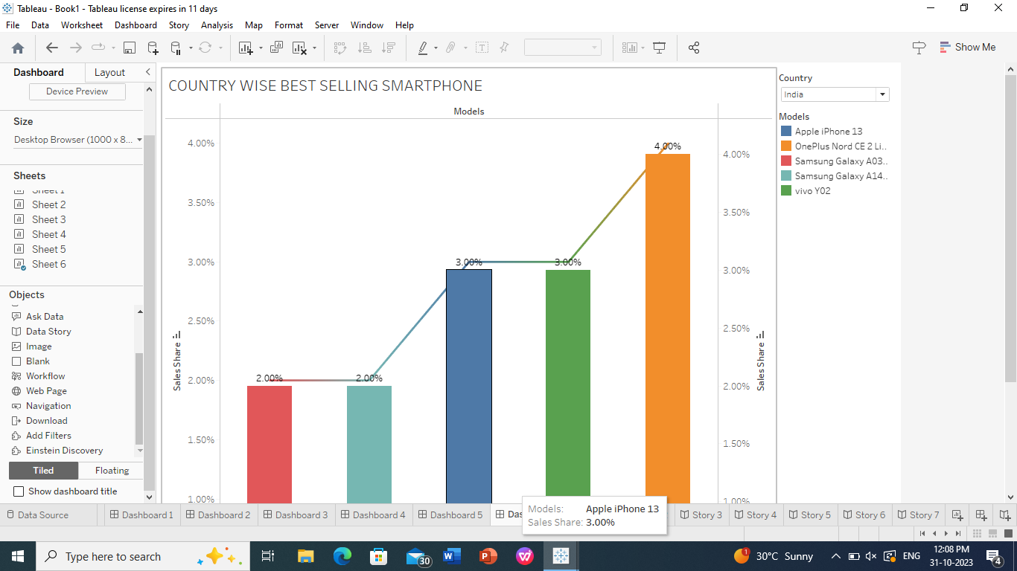

1. ADVANTAGES AND DISADVANTAGES

ADVANTAGES

* Technological Advancement

The iphone has driven technological progress by introducing cutting-edge features and hardware to the Indian market, spurring, innovation and competition among smartphone manufactures

* Quality and reliability

Apple’s reputation for quality and reliability has set higher standard for the entire smartphone industry, benefitting lndian consumers with better build devices.

* App ecosystem

The iphone’s popularity has fostered a robust app development ecosystem, providing Indian users with a wide range of apps and services for various needs.

DISADVANTAGES

* High cost

Iphones are relatively expensive, which can limit their accessibility to a significant portion of the Indian population.

* Economic Disparities

Owing an iphone can exacerbate economic inequalities as it becomes a symbol of affluence.

* Limited Customization

iOS offers limited customization compared to Android, which may not suit the preferences of some users.

1. APPLICATIONS

* Digital transformation
* App development
* Start up Ecosystem
* Educational Impact

1. CONCLUSION

In conclusion, the apple iphone impact on India is marked by technological development, economic growth, and digital literacy. It has transformed consumer behaviour and played a pivotal role in the development of India’s digital ecosystem. However, challenges such as affordability and e waste have also risen. The iphone’s influence is a testament to the complexiies of globalization and technology adoption in the country.

1. FUTURE SCOPE

The future scope of the apple iphone’s impact in India includes market expansion, local manufacturing, app development, digital inclusion, sustainability initiatives, and its role in education and healthcare.

As 5G technology is adopted, the iphone capabilities may further evolve, and increase competition will drive innovation. Apple is expected to adopt to meet the evolving demands of the Indian market.